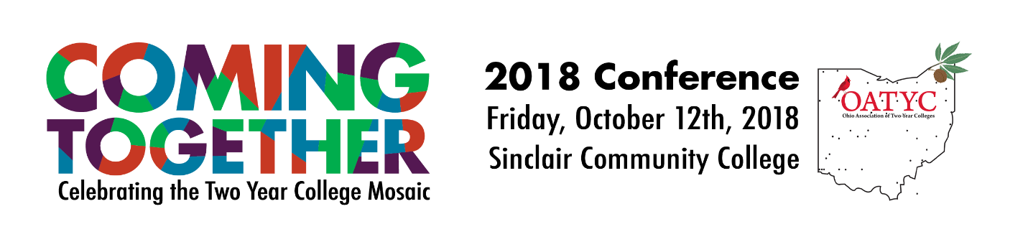

Total Due : $ .
To register by mail, fill out this form, and send it along with full payment to:
  - 2018 OATYC Conference, Sinclair Community College
Attn: Bursar Office, John Coyle
444 West Third Street, Dayton Ohio 45402-1460
Phone - 937-512-4620

* | First Name:
* | Last Name:
* | Title :
* | Address:
* | City, State, Zip: | , ,
* | Phone (Campus) : | - -
* | Cell: | - -
* | College :
 | Email Address:
* | Confirm the email:
* | Quantity:

